## TOWN OF DRUMHELLER

**BYLAW NO. 12.12**

BEING A BYLAW OF THE TOWN OF DRUMHELLER IN THE PROVINCE OF ALBERTA TO ADOPT AN AREA STRUCTURE PLAN

**WHEREAS:** pursuant to the provision of Section 633(1) of the ***Municipal Government Act***, R.S.A. 2000, Chapter M-26.1, a council may pass a bylaw for the purpose of adopting an area structure plan to provide a framework for subsequent subdivision and development of land within the Town to be known as:

“THE PORTION OF AERIAL, ROSEDALE AREA STRUCTURE PLAN”

**AND WHEREAS:** a Public Hearing was held on **September 10, 2012**, as required by Section 230 of the Municipal Government Act.

**NOW THEREFORE:** THE COUNCIL OF THE TOWN OF DRUMHELLER IN THE PROVINCE OF ALBERTA, DULY ASSEMBLED, ENACTS AS FOLLOWS:

1. This Bylaw may be cited as “The Town of Drumheller – PORTION OF AERIAL, ROSEDALE Area Structure Plan”.

2. Council adopts the PORTION OF AERIAL, ROSEDALE Area Structure Plan for those lands contained within the plan area.

3. This Bylaw takes effect on the date of the third and final reading.

READ A FIRST TIME THIS 27th DAY OF August , 2012.

READ A SECOND TIME THIS 10th DAY OF September, 2012.

READ A THIRD TIME AND PASSED THIS 10th DAY OF September, 2012.

________________________ _________________________

MAYOR CHIEF ADMINISTRATIVE OFFICER

TOWN OF DRUMHELLER

**BYLAW NUMBER #13.12**

BEING A BYLAW TO AMEND LAND USE BYLAW NO. 10-08 FOR THE TOWN OF DRUMHELLER IN THE PROVINCE OF ALBERTA.

**WHEREAS** pursuant to the provision of Section 639 of the ***Municipal Government Act***, RSA 2000, Chapter M-26, the Council of the Town of Drumheller (hereinafter called the Council), has adopted Land Use Bylaw No. 10-08;

**AND WHEREAS** the Council deems it desirable to amend Land Use Bylaw 10-08; and

**NOW THEREFORE** the Council hereby amends Land Use Bylaw No. 10-08 as follows:

Schedule A, Land Use District Map, by re-designating a portion of the S ½ Sec.28 - Twp. 28 - Rge 19 W4M in the Town of Drumheller from “UT” – Urban Transitional District to “SCR” – Suburb Community Residential District as shown on the plan below:

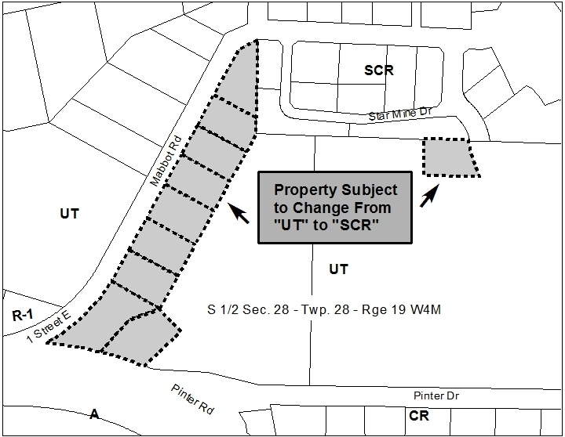

READ A FIRST TIME THIS 27th DAY OF August, 2012.

READ A SECOND TIME THIS 10th DAY OF September, 2012.

READ A THIRD TIME AND PASSED THIS __th DAY OF __________, 2012.

________________________ _______________________________

MAYOR CHIEF ADMINISTRATIVE OFFICER