ELGIN HILL

AREA STRUCTURE PLAN

BYLAW 20-06



Town of Drumheller

Prepared by: Palliser Regional Municipal Services
& Town of Drumheller

September 2006
Elgin Hill
Area Structure Plan

Outline

Introduction 1
  - Purpose 1

2 Study Area 2
2.1 Site Location 2
2.2 Ownership 3
2.3 Site Constraints 3

Development Concept 3
  - Goals & Objectives 3
  - Development Concept 4
  - Plan Statistics 4

Servicing 6
4.1 Road Network 6
4.2 Utility Servicing 6
4.3 Sanitary Sewer 6
4.4 Water 6
4.5 Storm Drainage 6

Implementation 7
  - Land Use Classification 7
  - Municipal Reserves 7
  - Trail Connections 9
  - Phasing 9
  - Development Guidelines 9

List of Figures

Figure 1 Study Area 1
Figure 2 Land Ownership 2
Figure 3 Development Concept 5
Figure 4 Land Use 8

Tables

Table 1 Land Ownership 2
Table 2 Plan Statistics 4

Introduction

This area structure plan is prepared to provide a future planning direction to the upper bench land of land know as Elgin Hill. Over the years a number of planning schemes have been prepared for this site. In 1985, the Elgin Hills Area Structure Plan (Bylaw 2-85) was adopted. For various reasons the land was never developed.

This plan is intended to replace the 1985 plan and provide an updated planning direction and guidelines that will provide for orderly grow of the area.

  - Purpose

The purpose of this plan is to provide future planning direction for the undeveloped bench area of land located east of Elgin Hill road and north of Seventh Avenue South West.

Several different landowners own portions of the land in the study area. As a result, it is very important for this plan to provide an overall direction that will allow the area to be developed in a cohesive and coordinated fashion. Development phasing will be dictated by development of adjacent lands.

Study Area

The study area is outlined on the air photo below.

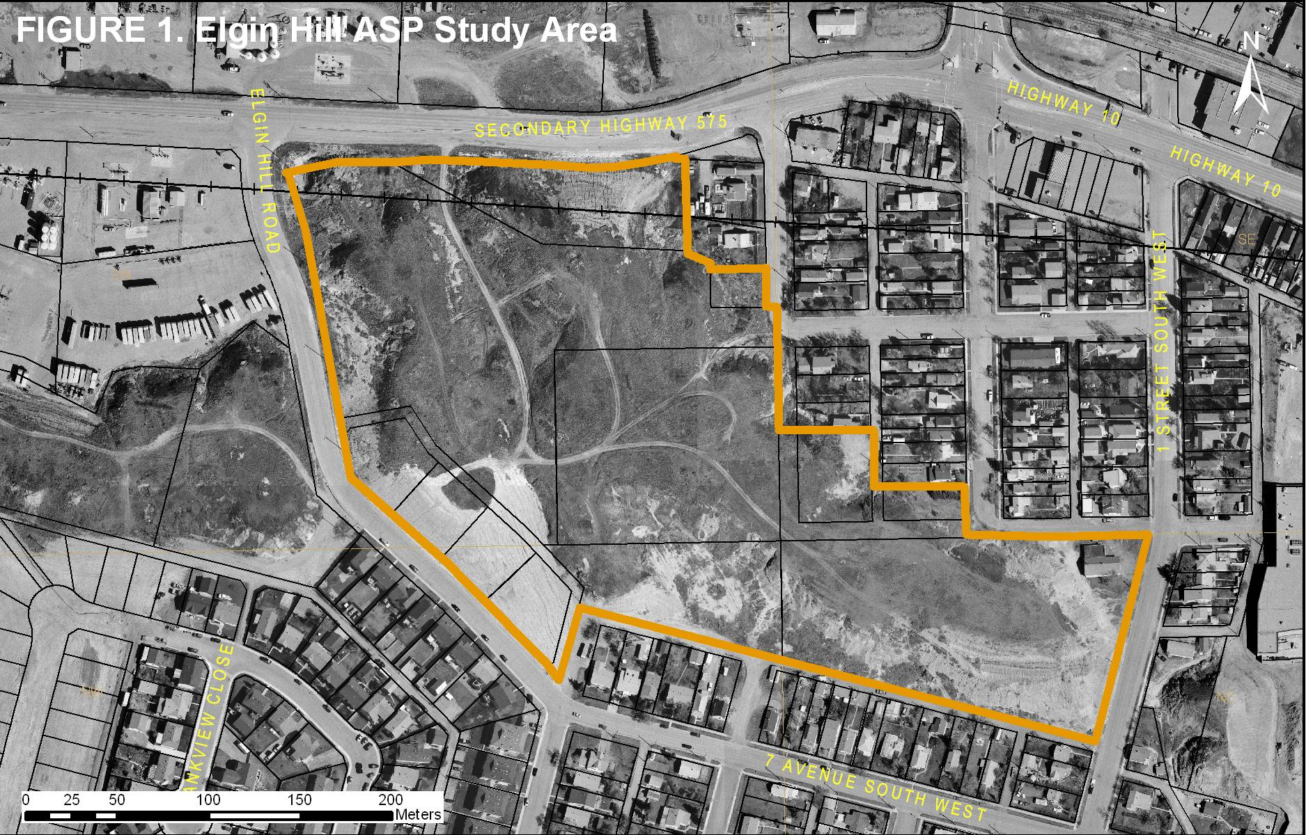

  - Ownership

The following table lists the landowners and their holdings. The Town of Drumheller owns the majority of the land in the study area. (See: Table 1 & Figure 2)

Table 1 Land Ownership

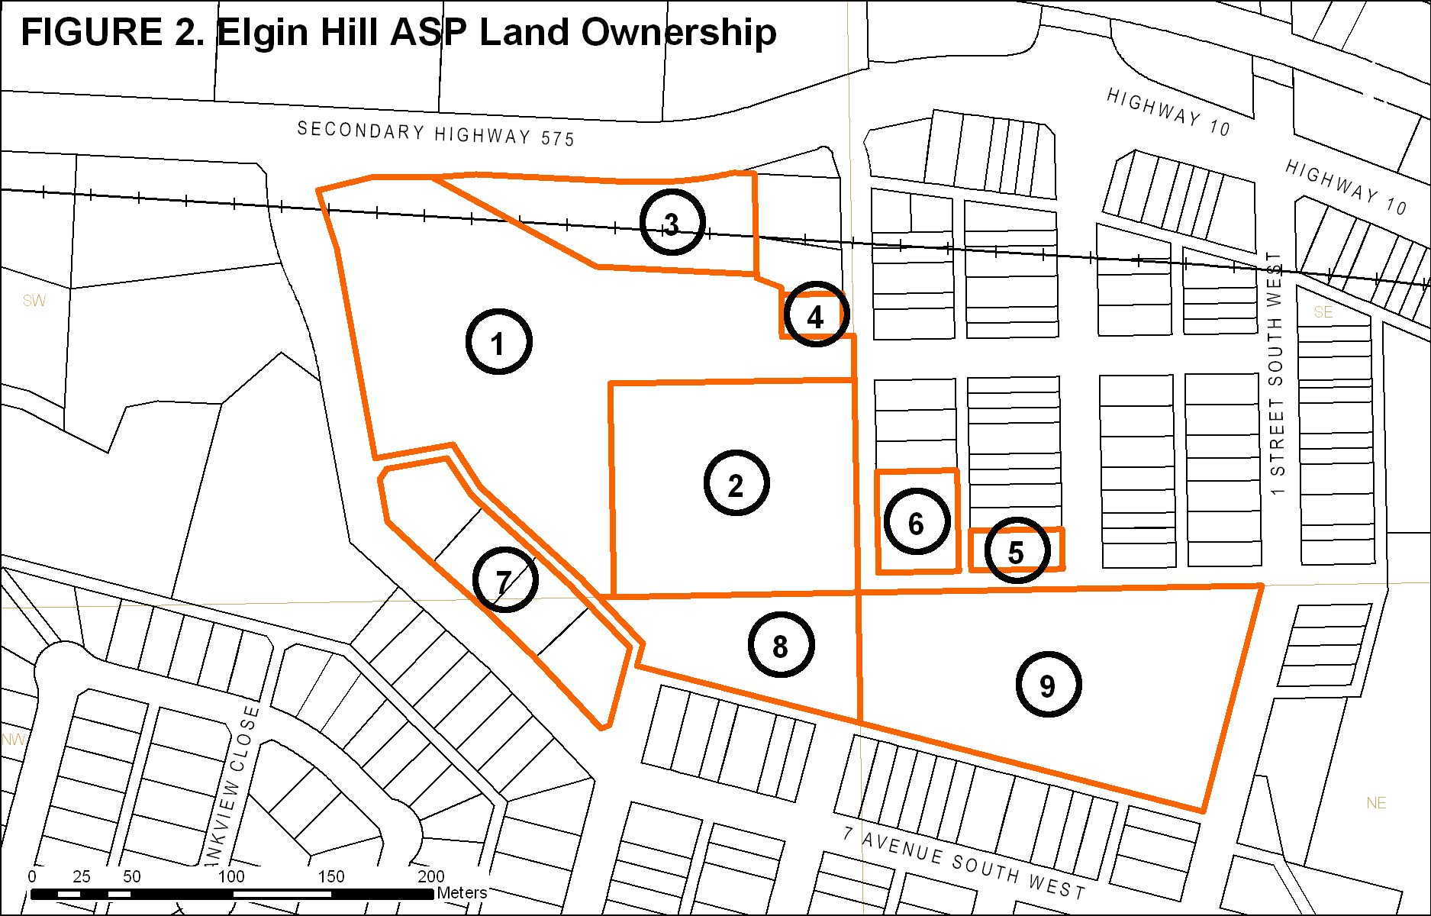

  - Site Constraints

The study area contains a relatively flat plateau of land surround by fairly steep slopes rising approximately 10 to 12 m above the surrounding area. The plateau area consists of undeveloped land that affords some tremendous view of the town and river valley. This area holds potential for some unique developments.

The steep slopes present some problems with regard to access to this site. The site also presents some engineering challenges with regard to serving, especially in terms of water pressure.

  - Soil Conditions

The site is underlain by the Edmonton Formation of Upper Cretaceous geological period. This formation consists mainly of stratified deposits of fine-grained sandstones, siltstones and mudstones. Coal seams may also be present. Local experience indicates that the upper layers of rock tend to be rotten and provide few problems for excavation. Very little bentonite is normally found in the sandy surface soils. However, basements will likely extend into bentonite soils, therefore, weeping tile and good surface drainage need to be considered at the construction stage.

2.4 Slope Stability

A preliminary assessment of the slope stability was conducted by Palm Engineering Ltd and based on experiences with similar hill formations; a danger of slumping is not anticipated. However, a danger of rocks breaking away and rolling down the hill and resulting erosion are concerns. Based on this preliminary review, it is recommended that all buildings be set back a minimum of 7.5 m from the edge of the escarpment. It is recommended that this area be maintained as an easement in favor of the Town to allow access and maintenance.

This strip should not be developed with trees or fences, but may include roads, parking lots, and landscaped area with grass, scrubs and flowerbeds. This area would not be a driving lane, but would allow access for equipment. Native grass should be retained along the edge of the escarpments; therefore extra care must be exercised at the construction stage.

At the development stage, it is recommended that a more detailed geotechnical study be conducted to confirm the stability of the slopes and the appropriate setback with regard each specific development.

- Development Concept

  - Plan Objectives

The principal objectives of this plan are:

- To develop a plan to guide the future development of this area.
- To establish appropriate development guidelines for this area.
- To establish a servicing concept for the area.

  - Development Concept

The development concept for this site is to establish an area of higher density residential on the upper bench. It is anticipated that house mix will consist of a number of town or row houses and apartments. Preliminary designs for the site indicate that it is possible to develop in the range of 150 plus dwelling unit in this upper area. The exact mix will be dictated by housing demands at the time of development. However, it is recommended development of this site be restricted to multiple dwellings, i.e. town houses or apartments.

The privately owned lands in Block 20, Plan 8611196 fronting on to Elgin Hill Road were previously subdivided into 4 residential lots. As part of this plan, these lots may be replotted into smaller lots to allow for the construction of duplexes or single family, consistent with the development across the road. The Town has advised that any development along the north side of Elgin Hill Road will be required to provide vehicular access and parking at the rear of the lots. To maintain consistency with the existing dwelling along the south side of Elgin Hill Road, dwelling constructed along this stretch of road will be required to front Elgin Hill Road

Access to the site will be via a cul-de-sac road extending from a high point on Elgin Hill Road up on to the flat bench land. This road will provide access to all land on the upper area. Each site will have direct access to this road, but some instances, individual developments may create their own private road to service their development.

The escarpment or slopes greater than 15% grade should be taken as environmental reserves (ER). The purpose of environmental reserve is to protect these areas from development and encroachment. Environmental Reserves may be left in their natural state or used for park purposes. If there is a potential that any of these areas may be developed or used for other purposes in the future, they should be dedicated as MR or some other more appropriate land use district. The exact amounts of ER to be taken from each property will be determined at the subdivision stage.

The concept shows a potential park in the northern portion of the site. The site is a draw that the town has been using to dispose of excess filling. The site is not suitable as a building site, but will work well for park or playground purpose. This site should be designated “MR’’ Municipal Reserve. As this draw is filled, this area may also be a suitable site for a trail down linking the subject site to South Railway Avenue.

  - Plan Statistics

Table 2 Plan Statistics

Land Owner | Total  Area | Developable  Area | Reserves | Escarpment
Town of Drumheller | 4.6 ha (11.5 ac) | 2.4 ha (5.9 ac) | 1.0 ha (2.5 ac) | 1.5 ha (3.7 ac)
D. James Goudy | 1.2 ha (2.9 ac) | 0.7 ha (1.6 ac) | 0.4 ha (0.9 ac) | 0.1 ha (0.3 ac)
Ed Lehn | 1.7 ha (4.2 ac) | 0.6 ha (1.6 ac) | 0.1 ha (0.2 ac) | 1.0 ha (2.4 ac)
Roads & Lanes | 0.3 ha (0.8 ac) | 0.2 ha (0.5 ac) | 0 ha (0 ac) | 0.1 ha (0.2 ac)
Total | 7.8 ha (19.3 ac) | 3.8 ha (9.4 ac) | 1.4 ha (3.5 ac) | 2.7 ha (6.7 ac)

Fig 3 Dev Concept see PDF insert in 2006 Bylaw File
4 Utility Servicing

The study area will be connected to town utilities. In the past, some utility services to this area were constrained by off site limitations.

  - Road Network

The plan is to create access to the site by creating a single road from Elgin Hill Road through Block 20, Plan 8611196 up on to the bench land. The road will terminate with a turnaround at the north end of Drum Body Works property. This road will basically be a single cul-de-sac for the entire development. The proposed layout minimizes the amount of roads, but still provides access to all properties.

Since this road is the only means of access and egress to this upper area, a right of way width of 18 m with an 11m a carriageway is recommended. A road of this size should be large enough to handle the traffic volumes and allow on street parking along parts of the right of way. As development proceeds and detailed designs are conducted, there may need to limit or restrict on street parking.

  - Sanitary Sewer

Sanitary Sewer from this area would flow by gravity into an existing line located in Elgin Hill Road. This line is used to handle the Newcastle area and should have the capacity to accommodate this development.

  - Water

Providing water service to this site presents some engineering issues. With the study area being higher than the surrounding area, low water pressure is being experienced. To maintain acceptable water pressures for the site, a higher-pressure water zone is required. Figure 3 shows a Booster Pump Site at the intersection of Fourth Street and Elgin Hill Road. Additional engineering is required to resolve the issues of using booster pumps for domestic & fire flows. To ensure adequate water is available for fire protection, lines may need to be looped. With higher density development envisioned, it is recommended that fire hydrants be installed at 150 m spacing. Buildings shall be restricted to a maximum 3-storey height to eliminate the need for separate booster pumps for fire flow.

  - Storm Drainage

The development of this site is not expected to increase the storm outfall. During the development stage, careful consideration must be given to storm outlets to the side of the hill, hillside erosion and their impact at the bottom of the hill.

  - Shallow Utilities

All shallow utilities are to be located underground. These are to be installed by the various franchise companies and are coordinated through a service agreement. These companies will need to take rock excavation into account.
5 Implementation

  - Land Use Classification

The majority of study area is currently classified “UT” - Urban Transitional in the Town of Drumheller Land Use Bylaw, with the exception of a strip of land along First Street that houses Drum Bodyworks is designated “M-1” Light Industrial District.

The land use bylaw requires an area structure plan be prepared prior to the site being reclassified to a more appropriate land use district. This plan has been prepared to satisfy this requirement.

The previous planning documents envisioned a higher density of development and proposed a variety of housing types including town houses and apartments. Considering the economics of servicing this area, this concept is valid. It is proposed that this plan allow for a variety of housing types ranging from duplexes or town houses to 3 storey apartments. To facilitate this type of development it is recommended the majority of the site be classified “R-3” Medium Density Residential District. [See: Figure 4]

It is also recommended the Drum Body Works land currently designated M-1 be reclassified to “R-1A” Residential District. By reclassifying this property to R-1A, it will allow development of this land to be compatible with the adjacent land uses. The current industrial building would then become a ‘legal nonconforming use’, which means its current use may be continued. However, if the present use is discontinued or changed, then any new development would be required to conform to the land use bylaw.

  - Municipal Reserves

As part of a subdivision, the undevelopable hillsides or escarpment lands should be taken as reserve. If the lands are such that they can never be developed and will likely be left in their natural state, consideration may be given to designating them Environmental Reserve.

Given the proposed density on the upper area, it is suggested there will be a need for some open space for uses a playground etc. The Town has been filling a draw that runs in a northerly direction towards South Railway Avenue. This area is not suitable for large structures; however, it would be suitable for park purposes and possibly for parking for adjacent developments.

The portion of Block 10, Plan 8311341 that lies below the escarpment has limited development potential, therefore it is proposed that it be designated as MR. Dedication of this land should be take into consideration during any land swaps.
Fig 4 Proposed Land Uses – see PDF insert in 2006 Bylaw File

  - Trail Connection

The fill area at the north end of the site is an ideal location to creation a trail connection from this site to the rest of the town. A trail could be created down the draw to the north to South Railway Avenue and then into the downtown area. Trail construction needs to take into consideration the potential erosion of any escarpment area.

  - Phasing

Development of this area will proceed progressively from Elgin Hill Road towards First Street South West. For development to occur in an orderly and economical manner the first phase will need to be developed to allow commencement of the next phase. If more than one landowner develops the site, coordination will be required to ensure access and utilities service extensions are worked out. Over sizing and cost sharing agreements may be required in servicing agreements for this area. It is important that all developments follow this plan in terms of access and servicing so future developments are not jeopardized.

Should a landowner wish to proceed with the development on their lands that would result in of an out of sequence development, then that developer would be required to front end all development costs. Portions of these costs may then be recovered as the intermediate phases proceed. As part of a service agreement, the Town may include an ‘endeavor to assist’ clause.

  - Development Guidelines

As previously mentioned, water pressure to this site may dictate building heights. Considering this water pressure issue and fire fighting it is recommended that no buildings be constructed over three stories in height.

Taking into account the relatively confined area of the site and the potential higher density, parking requirements need to be carefully considered at the time of development. Adequate parking for owners, tenants and visitors must be considered. It is recommended the following minimum standard be considered for this area:

Apartments: 1 stall per dwelling unit, plus 1 stall per 4 units for visitor parking.
Town Houses: 2 stalls per dwelling unit plus 1 stall per 5 units for visitor parking.
Duplexes: 2 stalls per dwelling unit.

Portions of this property provide for some tremendous views of the Town and river valley Coupled with the fact, that a higher density of development is anticipated; the plan proposes that the site be developed with upscale or high quality developments.

  - Land Exchange

The study area is currently owned by a number of separate parties. For this area to develop it will be necessary for the Town and some of the landowners to work out deals to exchange land. For example the road connection into the study area crosses land currently owned by James Goudy. It is proposed that in exchange for the land required to create this road, Mr. Goudy will receive some land from the Town on the south side of the proposed road. This land would be consolidated with some of Mr. Goudy’s land to create a suitable building site. As part of the land exchange, portions of the existing road (Fourth Street SW) and the lane at the rear of the lots facing onto Elgin Hill should be closed and consolidated with the adjacent lots. This can take place at the subdivision stage.

The details of the land exchanges will not form part of this area structure plan and will be negotiated separately. It is recommended that any lands involved in an exchange be surveyed, to determine exact areas.

